


Flash 8

How to Re-use a Youtube Video

Download the Youtube video as an FLV file using an online tool such as:
Catchvideo.net

Create a new Flash document and immediately save it in the same folder that contains the flv file that you downloaded.

Click File → Import → Import Video….

When a window appears choose: ‘On your computer’ and click ‘Browse…’

When you have found your flv file click on ‘Open’ and the full address of the flv file appears in the dialogue box

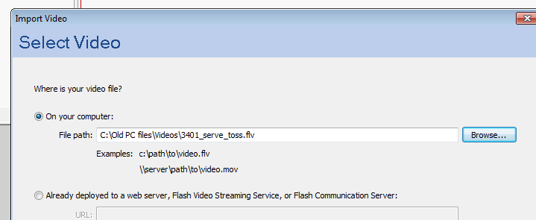

Shorten the address so that it only contains the name of the video followed by .flv

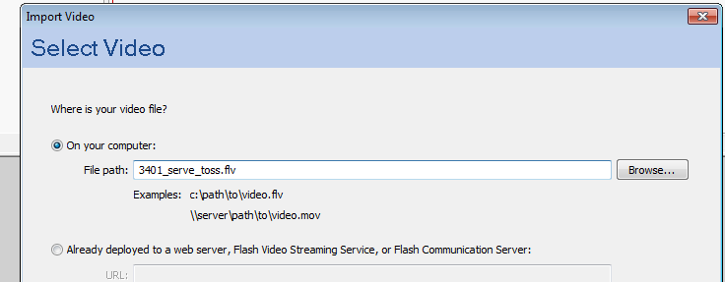

Click ‘Next’

Choose ‘Progressive download from a web server’

Click ‘Next’

Choose ‘Medium Quality’

Click ‘Next’

Choose a skin (for example ‘ArcticExternalAll.swf’)

Click ‘Next’
In the next window click ‘Finish’

The video will only work properly if your new Flash document is in the same folder as the flv file. (The flv file must always travel with the Flash file if you transfer it to another location)

In Flash, adjust the Document dimensions to match the size of the video, allowing extra room for the video control bar.

Click Modify → Document… → Dimensions

Save and Publish

